Step 1- Go to your admin dashboard-users-list- add user.
(admin.jamworkout.com/auth)
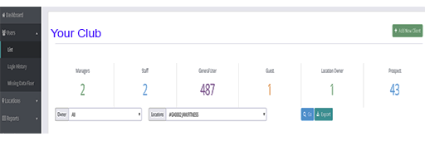

Step 2- Fill out the form, and add the heart rate monitor ID.
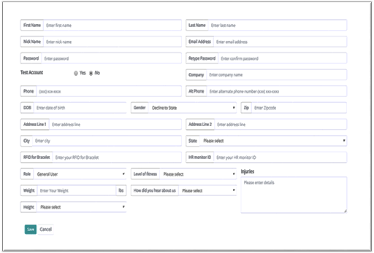

Step 3- You are DONE!
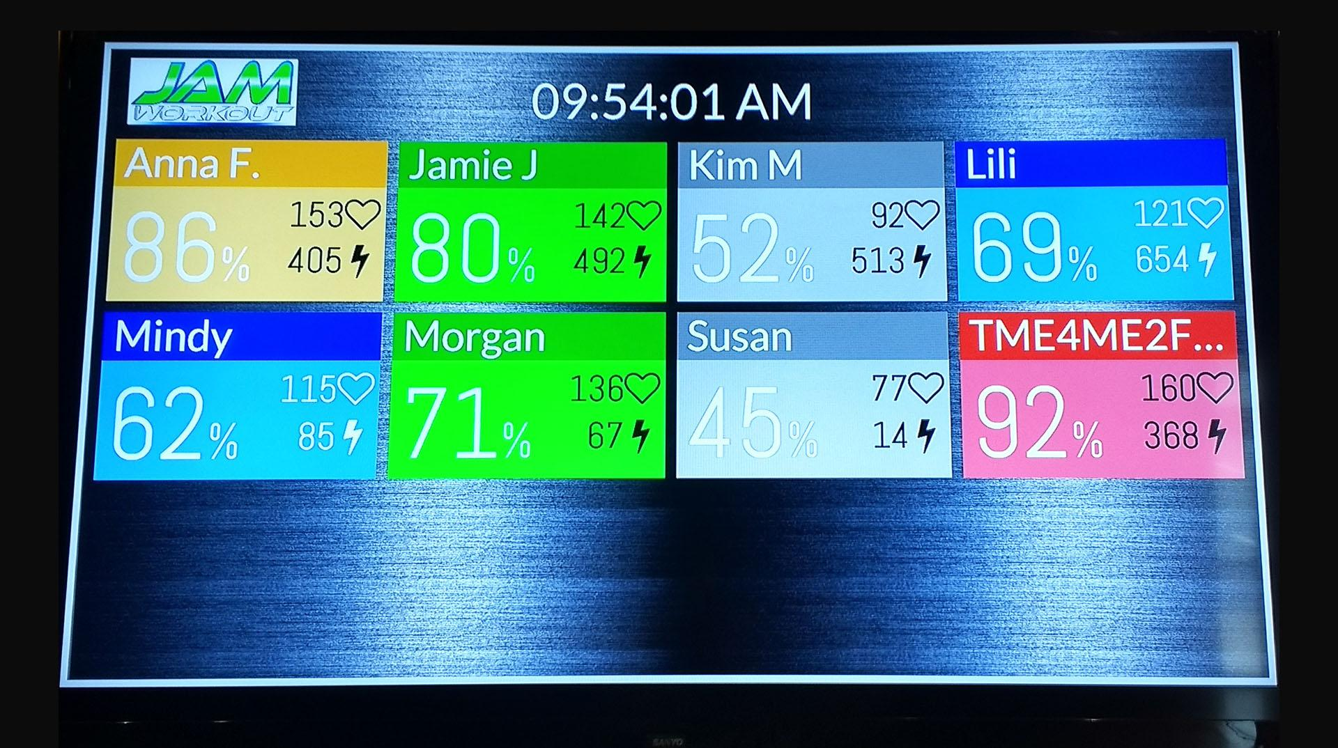
Now get out there and workout using your new heart rate monitoring system.

